Assignment 6-2: Cartpole Revisited

Dhiraj Gurung
Bachelor of Science in Computer Science, Southern New Hampshire University
CS370
Jason Richard
February 18, 2026

Assignment 6-2: Cartpole Revisited
REINFORCE Algorithm:
The REINFORCE algorithm is a method used in reinforcement learning to improve an agent’s decision-making (GeeksforGeeks, 2025). The algorithm teaches the agent to understand and estimate what the best possible action it can take is. The agent begins by completing episodes to collect information on the returns and updating the policy parameters. These steps are repeated for several episodes to help the agent learn better. We can use the REINFORCE algorithm to teach an agent how to solve the cartpole problem by running the program for many episodes to see how the agent learns and adapts the policy. Chris Yoon shows how the agent can learn to balance the pole for longer periods of time by showing how the agent learned the policy over 5000 episodes (Yoon, 2018). In Figure 1, we can see that over 5000 episodes, the agent learns to balance the pole for longer durations as the agent learns from their past episode performances.

Figure 1
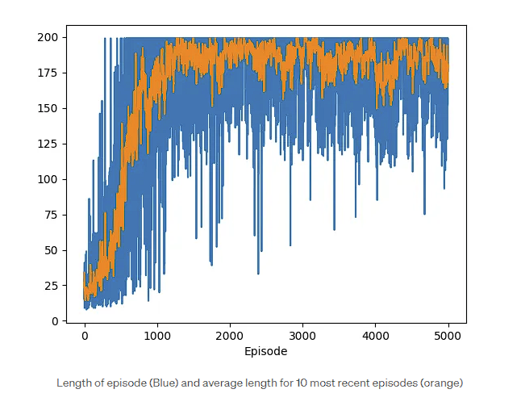
Note: Length of episode (Blue) and average length for 10 most recent episodes (orange) by Chris Yoon, 2018
Advantage Actor Critic Algorithm:
The Advantage Actor Critic Algorithm (A2C) combines policy and value-based algorithms to train the agent (Wang, 2021). In this approach, the policy or the actor chooses what actions to take, and once that action is taken, the critic or the value function will evaluate the action. In the A2C reinforcement approach, the advantage function is used to calculate a prediction error, the difference between what the agent expected to happen and what actually happened. This information helps train the agent to make better decisions in future episodes. In the cartpole problem, the agent is trained by getting feedback from the critic. As it makes decisions that help to balance the cartpole for longer, the critic will evaluate the actions more favorably. This will encourage the agent to make more of those decisions. Conversely, if the agent makes decisions that do not help balance the cartpole, then the critic will evaluate those decisions negatively, and, moving forward, the agent will try new actions instead.
Policy Gradient vs. Value-Based Approach:
Policy gradient approaches involve algorithms that learn a policy, or a strategy for choosing the next action (Milvus, n.d.). Crucially, they do this without relying on intermediate value functions. This means that, unlike a value-based approach, the actions taken are not based on the calculated expected returns for that action (Phronetic AI, n.d.). The advantage of using a policy-based approach is that it can handle continuous action spaces and learn stochastic policies more easily, but at the cost of requiring more data and having a high variance in its estimation. The advantage to value based approaches are that they can make decisions with less data and are great in discrete spaces, where there are a limited number of actions to perform. However, value-based approaches tend to struggle with continuous or high-dimensional action spaces, and their implicit policies mean that prior knowledge is difficult to implement into the system.
Actor-Critic Approaches vs. Value and Policy-Based Approaches:
The A2C differs from the value and policy-based approaches because it chooses to incorporate both rather than opting for one or the other. An A2C algorithm tries to combine the best of both worlds by utilizing both policy and value-based approaches (Wang, 2021). The actor represents the policy-based approach, and the critic represents the value function used to estimate the expected cumulative rewards. The hybrid nature of A2C allows for improved sample efficiency, allowing for fewer runs to gain the desired results.
References:
GeeksforGeeks. (2025, October 9). Reinforce algorithm. GeeksforGeeks. https://www.geeksforgeeks.org/machine-learning/reinforce-algorithm/
Milvus. (n.d.). What are policy-based methods in reinforcement learning?. Milvus. https://milvus.io/ai-quick-reference/what-are-policybased-methods-in-reinforcement-learning
Phronetic AI. (n.d.). Chapter 2: Value based reinforcement learning vs policy based reinforcement learning. Phronetic AI. https://www.phronetic.ai/blogs/chapter-2-value-based-reinforcement-learning-vs-policy-based-reinforcement-learning
Wang, M. (2021, January 22). Advantage actor critic tutorial: MINA2C. Towards Data Science. https://towardsdatascience.com/advantage-actor-critic-tutorial-mina2c-7a3249962fc8/
Yoon, C. (2018, December 29). Deriving policy gradients and implementing reinforce. Medium. https://medium.com/@thechrisyoon/deriving-policy-gradients-and-implementing-reinforce-f887949bd63

